**Predictive Analytics and Data Mining**

**Peer-graded Assignment: Module 4 Peer Review Assignment**

**Aya Anisa Dwinidasari – February 12nd, 2021**

1. Step 1: read the data and adjust the partition and input-target file type

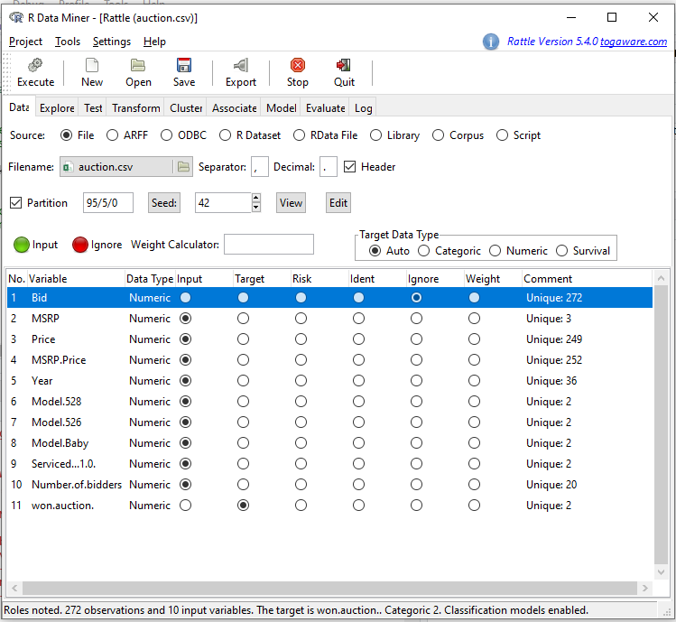

1. Create the Model forest in default parameter.

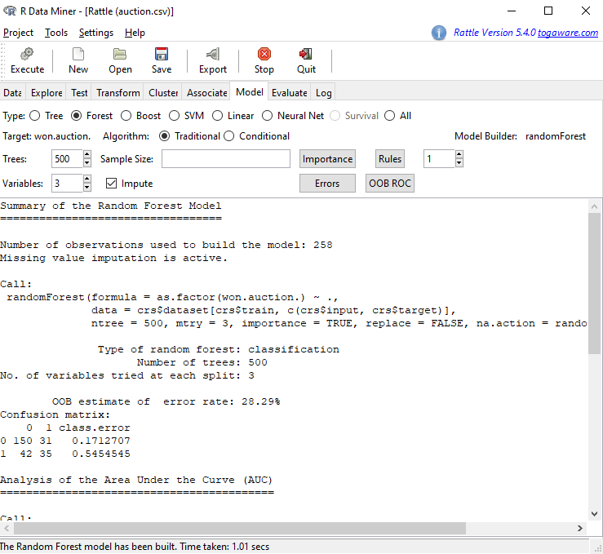

1. Export the csv file on the Evaluate (validation-probability-identifiers)

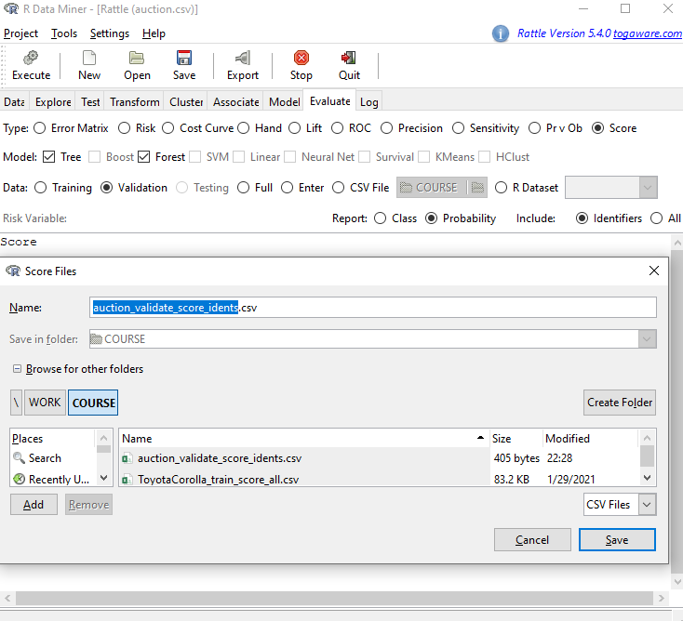

1. Open the csv exported file and calculate the error rate by iterating cut off value to get the optimum value. It can be defined that the optimum cut off is 0.4. 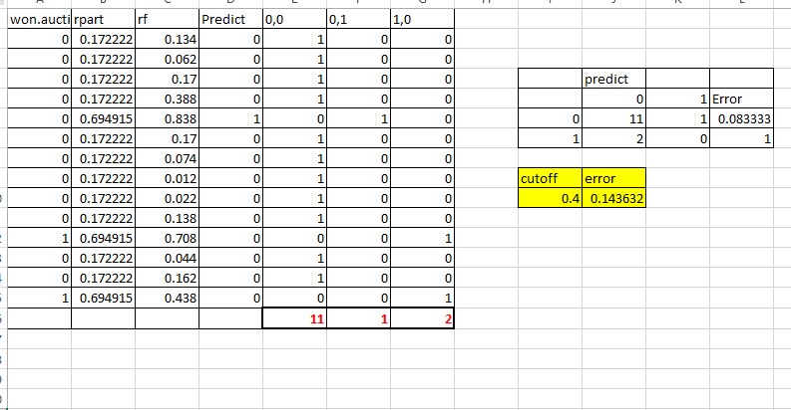
2. From the data above, the actual outcome (“won”) with the predicted outcome (by specifying a cutoff probability (“rf”) value such that if the “rf” is above the cutoff, the predicted outcome is “won”=1. Then, I compared the actual outcome with the predicted outcome to see how accurate our predictions are.